**PROGRESS TEST**   
Subject code: DBI202   
Duration : 85 minutes

**Requirements:**   
+ Write the code on 1 file, named the file: **ProgressTest_DBI202.sql**

+ Download the file **DB_ ProgressTest.sql** and execute it to create the database and the tables that are already in the file.

+ Submit your test with 2 files: a sql file as **ProgressTest** _DBI202.sql and a word file as ERD.docx which contains your ERD at question 1.

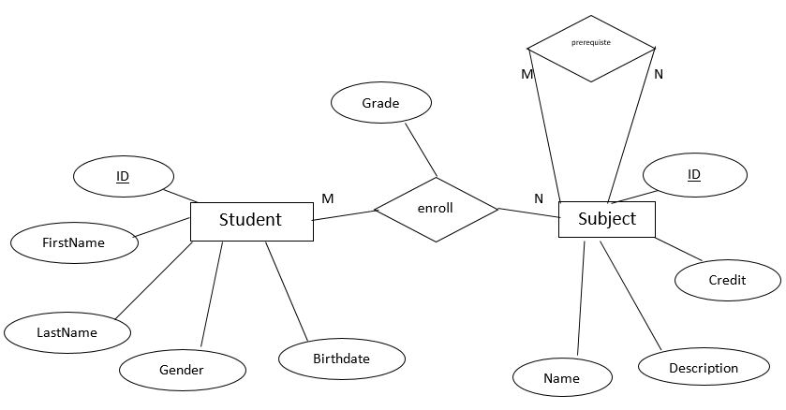

1. Based on the above ERD, you must add an entity which express the following statement (2 marks)

A student belong to a class, and the class has many students. Some attributes of the class are: ID, Name, SchoolYear, Number of Student.

1. Write a create the structure table for the entity which you added the ERD, with the following constraint: Name must be unique and NumberOfStudent must be greater than zero. (1 mark)

Write some code to insert at least 5 records into the table and related table in its relationship. (0.5 mark)

1. Write a query to select information of a student with ID, Full Name, Age

The result is ordered by **age** (**ascending**) then by **ID** (**descending**). (0.5 mark)

1. Write a query to select all information of student with their grade (1 mark)

Required columns in the result: Full Name, Subject Name, Grade.

1. Write a query to count total of credits that a student who enrolled with the grade must not be ‘F’. (1 mark)
2. Create a user defined stored procedure with the name usp_getNumberOfStudent

of a class. (Number of student is a calculate column).

Required columns in the result: ID, Full Name, Class Name, Number of students